**Experiment No. 8 Date:**

**Aim :** To write a program for Binary 4 bit up/down counter in VHDL.

**Apparatus :** PC, XILINXv5.2e software

**Theory:** Logic circuit whose outputs depend upon circuit inputs as well as previous values of circuit outputs described as their present states are known as sequential logic circuits. A sequential system can be defined in terms of its inputs and present state. That is, the next state of the sequential system can be determined from these two quantities.

A counter is a device which stores the number of times a particular event or process has occurred, often in relationship to a clock signal. There are two types of counters:

1. Up counter
2. Down counter



Fig 1: up/down counter

Up counter: A device that increases the current value by an increment of some specified value.

Down counter: A device that decreases the current value by an decrement of some specified value.

**FLOW DIAGRAM:**

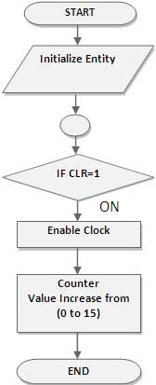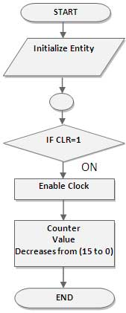

Fig 2: 4 bit up/down counter flow diagram

**Truth table:**

|  |  |  |
| --- | --- | --- |
| **Present state** | **Next state(up counter)** | **Next state(down counter)** |
| 0000 | 0001 | 1111 |
| 0001 | 0010 | 0000 |
| 0010 | 0011 | 0001 |
| 0011 | 0100 | 0010 |
| 0100 | 0101 | 0011 |
| 0101 | 0110 | 0100 |
| 0110 | 0111 | 0101 |
| 0111 | 1000 | 0110 |
| 1000 | 1001 | 0111 |
| 1001 | 1010 | 1000 |
| 1010 | 1011 | 1001 |
| 1011 | 1100 | 1010 |
| 1100 | 1101 | 1011 |
| 1101 | 1110 | 1100 |
| 1110 | 1111 | 1101 |
| 1111 | 0000 | 1110 |

Table 1: Binary 4 bit up/down counter

**Procedure :** 1) Write program for the circuit in VHDL.

2) Check syntax and synthesize the program.

3)Simulate the program and verify the circuit by applying different combinations of inputs.

**Result :**

**Conclusion :**